Deals Deployment Guide
Version 1.0
Created on: Wednesday, July 15, 2009

Pre-requites

- DIS 2.5.1 or above version installed on the box and DIS services running.
- Able to connect to the ftp site from the destination machine.

Deals Installation

1. Create Deals Databases

All the database scripts are available inside the DBScripts folder. Go inside the folder and execute the RunSqlScripts.exe utility to create the databases. This will create all the databases and all the database objects [tables, store procedures, views] related to Deals.

Steps:

- Go inside the DBScripts folder and click the RunSqlScripts.exe
- Once click, it will ask for the DB file path and Log file path. You can copy paste the path, once
provided it will create the databases in the mentioned path.

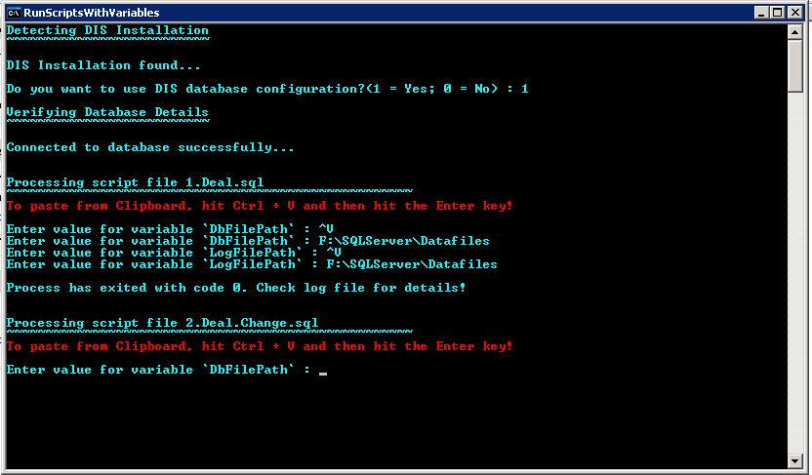

2. Run the Deals Setup.

Run the Setup “Deals.msi” to install the Deals on the server.

3. Configure DIS metadata on [DataIngestionInfrastructure] database to run Deals. [Optional]

3.1 Update the EmailNotifierInfo, for DIS to send Emails

The data column’s xml string is to be edited.

<EmailNotifierFeedSpcData Subject="Mailer task" Body="Mail body" Priority="Normal">
<Recipients>
<string>email1@thomson.com</string>
<string> email2@thomson.com</string>
</Recipients>
</EmailNotifierFeedSpcData>

Add the required email id to the Recipents/string Node

- Start the Seeding Process [Manual Process]

The Seeding [Full load] files are available in the ftp location for download. The seed file is MA_TRDW_20090622.zip. Download this file manually and run Deal_Hist Data Feed from ETL Driver.

Fresh Seeding process will complete in 14 hours approximately.

Once the seeding process is complete you can start running the incremental feed.

Note:

Feed Schedule

- Deal_Daily is scheduled to run from Tuesday to Saturday at 10:30:00 GMT. Sunday and Monday it’s off and won’t run any feed.

- Deal_Hist is scheduled to run every Quarter on Monday that comes next to first Saturday at 12:00:00 GMT.

FTP Details

- The Production FTP : 199.224.137.114
- Login: trdw
- Password: feed123
- Folder : /

